**PROJECT REPORT**

**1. INTRODUCTION**

**1.1 OVERVIEW**

The hotel industry is a broad category of businesses that provide lodging services for travellers and

tourists. This can include a wide range of establishments, from luxury resorts to budget-friendly motels, as

well as extended stay hotels, boutique hotels, and more. Hotels can be found in nearly every corner of the

world, and are often a major component of the tourism and travel industry in a given area.

Radisson owns multiple five-star hotels across India. They have been in the hospitality industry for

the past 100 years. Due to strategic moves from other competitors and ineffective decision-making

in management, Radisson is losing its market share and revenue in the luxury/business hotels

category. As a strategic move, the managing director of Radisson wanted to incorporate Business

and Data Intelligence in order to regain their market share and revenue. Our task is to create an

analytics dashboard & story to provide them insights to make better business decisions.

**1.2 PURPOSE**

To create an analytics dashboard & story to provide them insights to make better business

decisions.

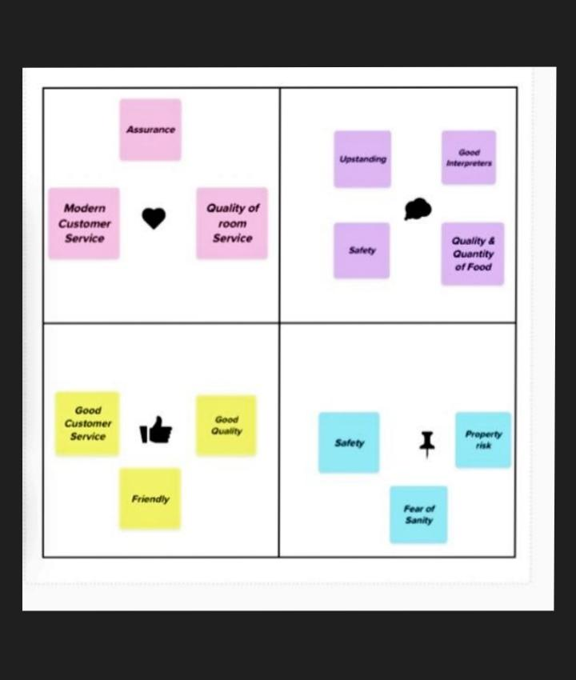**2.PROBLEM DEFINITION &**

**DESIGN THINKING**

**2.1 EMPATHY MAP**

**2.2 IDEATION &**

**BRAINSTORMING MAP**

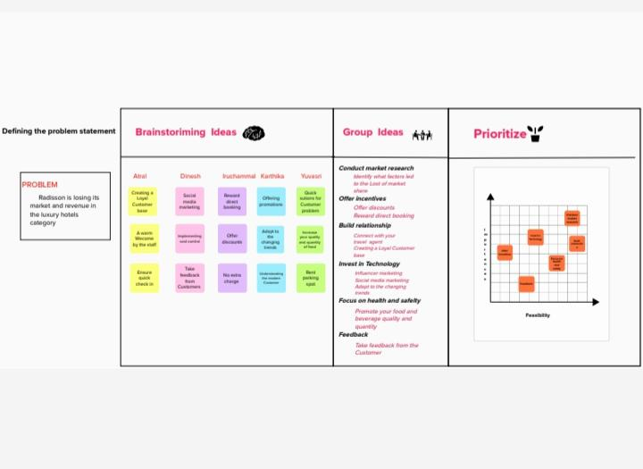

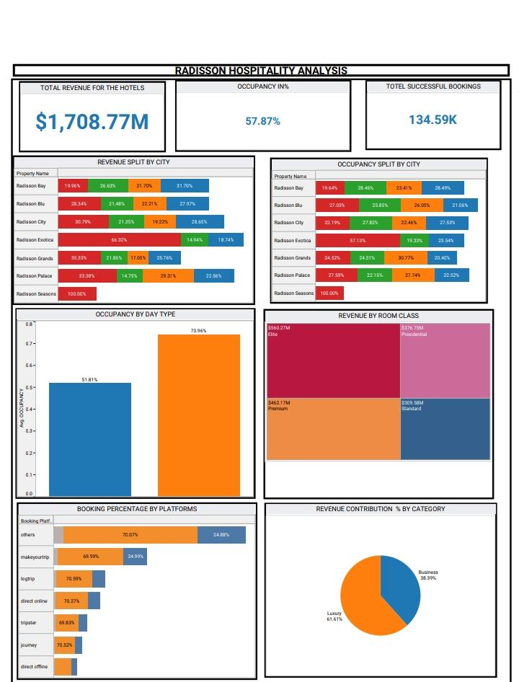**3.RESULTS DASHBOARD**

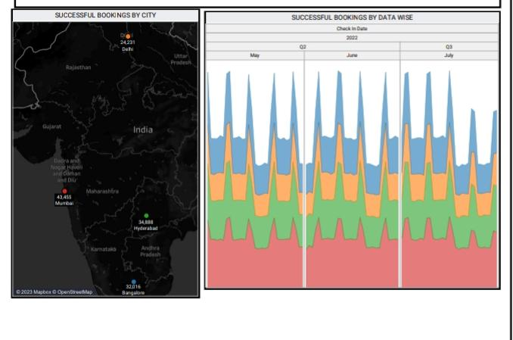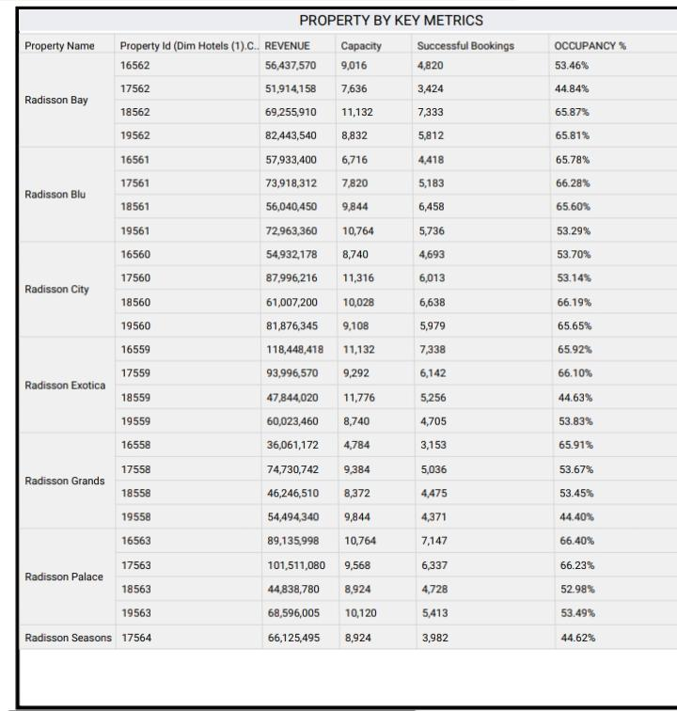

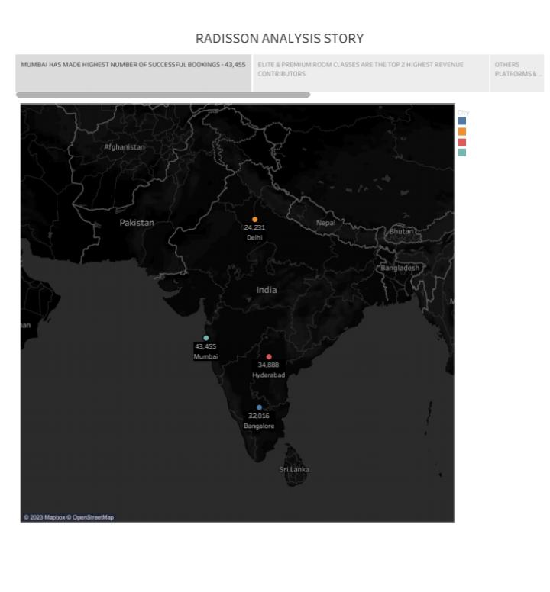**STORY**

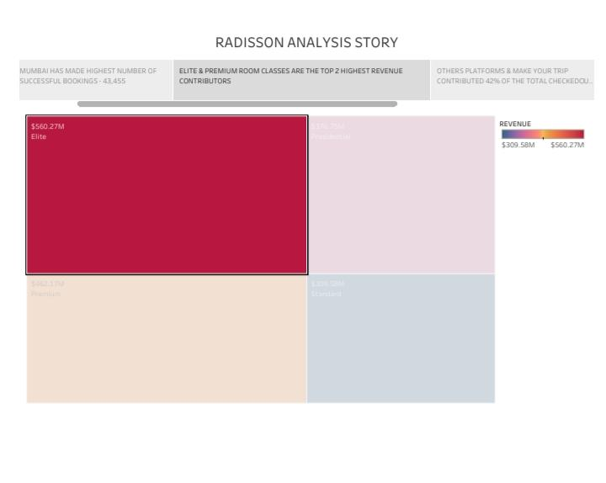

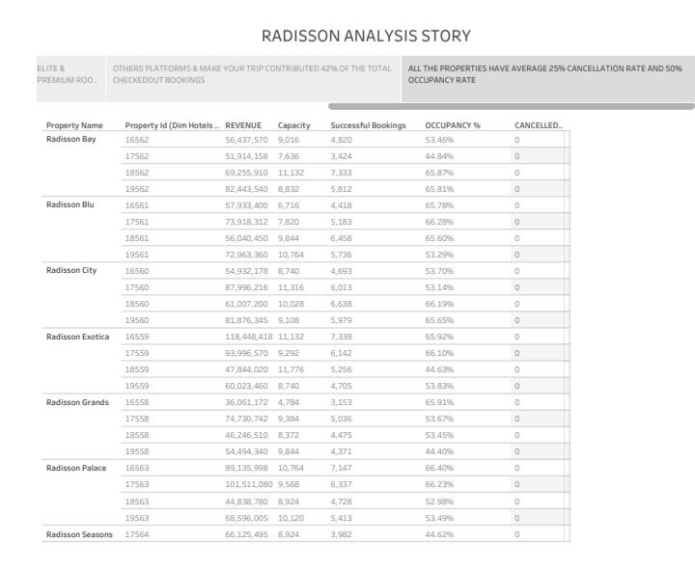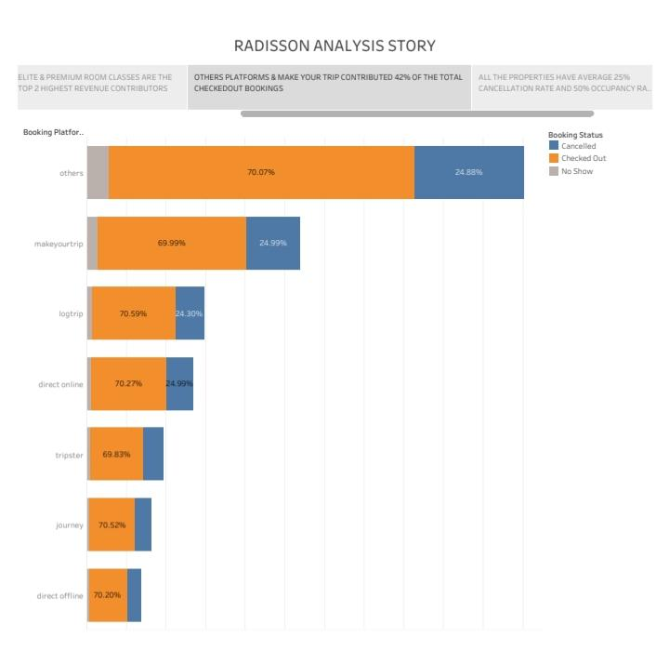

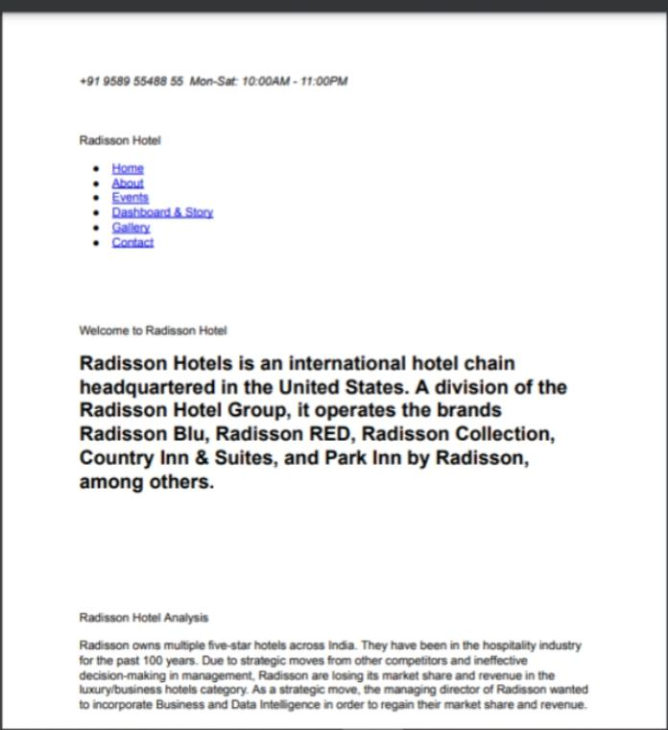**WEB LINK**

**ADVANTAGES**

* **Helps us to compare performance**

**and track changes over time**

* **The graph shows distribution and**

**relationships**

* **Make breakdown of revenue and**

**customer demographics**

**identification more easier.**

**DISADVANTAGES**

* **It mostly analysis general**

**trends, which means it tends to**

**ignore individual prices.**

* **Revenue impact undercutting**

**potential REVENUES BY DISCOUNTS.**

**APPLICATIONS**

**PROVIDE INSIGHTS TO MAKE BETTER**

**BUSINESS DECISION .**

**CONCLUSION**

**This project helps hotel managers get a full**

**overview of the hotel key metrics in a**

**glimpse. Check the bookings' source and the**

**financial status against your targets. On a**

**daily or monthly basis, you can check the**

**revenue figures and forecast the numbers for**

**the upcoming months.**

**FUTURE SCOPE**

* **Improving the speed of tableau**

**software.**

* **Allowing the permittable users**

**to edit the workbooks.**

* **Increasing the license time for**

**servers.**

* **ssss giving downloading option in tableau software**